WEEK 1 INTERNSHIP TASK
Data Acquisition and Pre-processing in Python
Project: Customer Churn Data Pre-processing
Submitted by: K. Avinash
Program: B.Tech Computer Science and Engineering
Domain: Data Analytics and Machine Learning
Week: 1
Internship Name :- Virtual Data Science Apprentice Intern
Introduction
Data preprocessing is an important stage in the data science and machine learning workflow. Raw datasets may contain missing values, inconsistent data types, duplicate records, categorical variables, and numerical variables with different scales. Proper preprocessing helps improve data quality and prepares the dataset for further analysis and machine learning.
The objective of this Week 1 task is to develop a complete data acquisition and preprocessing pipeline using Python. A customer churn dataset was selected because it contains demographic, service usage, contract, billing, and customer retention information that can be used for data analysis and machine learning.
Objective
- Acquire a publicly available dataset.
- Understand the structure and characteristics of the dataset.
- Identify and handle missing values.
- Check for duplicate records.
- Convert inappropriate data types.
- Detect potential outliers.
- Encode categorical variables.
- Normalize numerical features.
- Analyze relationships between features and the target variable.
- Validate the final processed dataset.
- Document the complete preprocessing workflow.
Dataset selection
The dataset selected for this project is a Customer Churn dataset containing information about customers, their demographic characteristics, services, contracts, billing information, and churn status.
Attributes | Description
Dataset | Customer Churn Dataset
Records | 7,043
Original Features | 21
Target Variable | Churn
Datatype | Mixed Categorical and Numerical
Domain | Customer Analytics/Telecommunications

Customer churn prediction is an important business problem because retaining existing customers can be more cost-effective than acquiring new customers. The dataset provides information that can be used to understand customer behavior and identify factors associated with churn.
[Source]: "https://raw.githubusercontent.com/IBM/telco-customer-churn-on-icp4d/master/data/Telco-Customer-Churn.csv"

Tools and Technology Used
Tool/Library | Purpose
Python | Programming Language
Pandas | Data loading , cleaning and manipulation
Numpy | Numerical Operations
Matplotlib | Data visualizations
Scikit-learn | Scaling and Preprocessing
Google Colab | Development Environment

Data Acquisition
The dataset was obtained from a publicly available data repository. The data was downloaded in CSV format and loaded into Python using the Pandas library.
Code:
url = "https://raw.githubusercontent.com/IBM/telco-customer-churn-on-icp4d/master/data/Telco-Customer-Churn.csv"
df = pd.read_csv(url)

print("Dataset loaded successfully")
print("Shape:",df.shape)
df.head()

The dataset was successfully loaded into a Pandas DataFrame. The initial dataset contained 7,043 records and 21 columns.
Initial Data Exploration
1.df.shape
Shape: (7043, 21)
2. df.info()
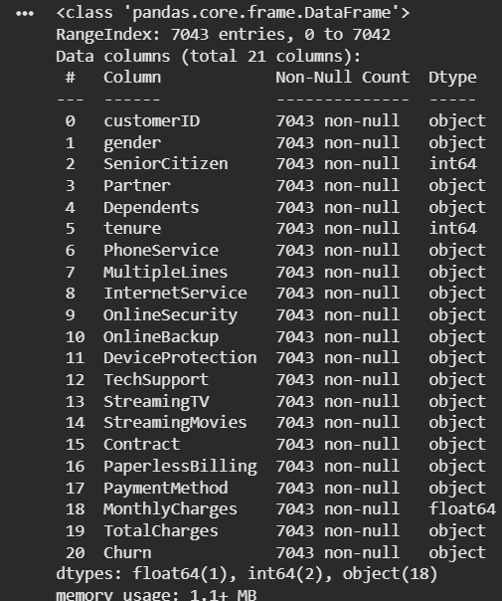
3. df.head()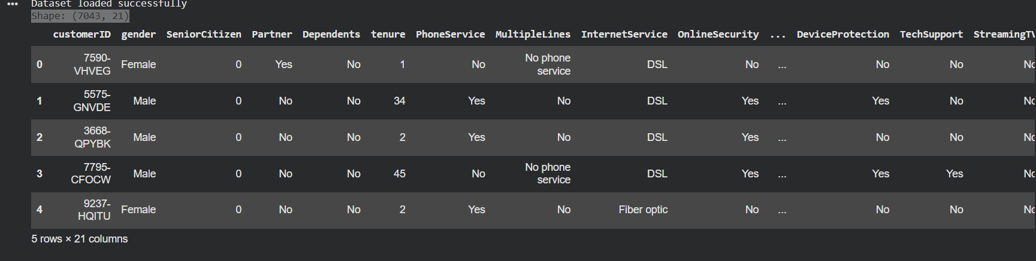
Initial exploration was performed to understand the number of observations, variables, data types, and overall structure of the dataset.

Missing Values Analysis
During data cleaning, the TotalCharges column was converted from object/string format to numeric format. Invalid or blank values were converted to NaN using errors="coerce". This revealed 11 missing values. These records were then handled during the cleaning process, resulting in zero missing values in the cleaned dataset.
df.isnull().sum()
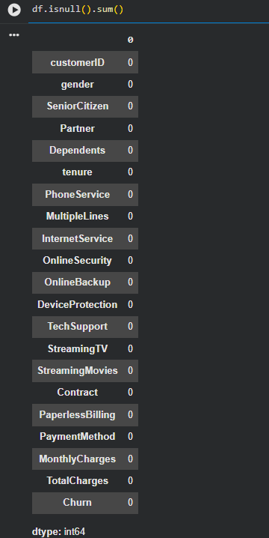
Code for conversion
df["TotalCharges"] = pd.to_numeric(df["TotalCharges"], errors="coerce")

print(df["TotalCharges"].dtype)

print("Missing values after conversion:",
df["TotalCharges"].isnull().sum())
output
float64
Missing values after conversion: 11
Duplicate Analysis
Duplicate records were checked using the complete original dataset, including the unique customerID field. No exact duplicate customer records were found.
Output
Duplicates in original dataset: 0
During feature transformation, the unique customerID column was removed because it is an identifier rather than a predictive feature. After removing this identifier, some customers had identical values across all remaining features. This resulted in 22 rows being identified as duplicate feature records.
Output
Duplicate feature profiles: 33
Profiles with different Churn values: 18
Further investigation showed 33 repeated feature profiles, with 18 profiles having different churn outcomes. This confirmed that these were not necessarily duplicate customer records. They represented different customers who happened to have identical observable characteristics. Therefore, these records were retained rather than deleted.

Datatype Conversion
df["TotalCharges"] = pd.to_numeric(df["TotalCharges"], errors="coerce")

print(df["TotalCharges"].dtype)

print("Missing values after conversion:",
df["TotalCharges"].isnull().sum())
Numerical variables were converted to appropriate numerical data types to enable statistical analysis and machine learning preprocessing.

Outlier Detection
Method : I have used the IQR method to detect the outliers
IQR = Q3-Q1
Lower Bound = Q1-1.5(IQR)
Upper Bound = Q3+1.5(IQR)
Feature | Number of outliers
tenure | 0
MonthlyCharges | 0
TotalCharges | 0

The IQR method identified no outliers in tenure, MonthlyCharges, or TotalCharges. Box plots were also used to visually verify the results. Since no outliers were detected, no observations were removed or modified during this stage.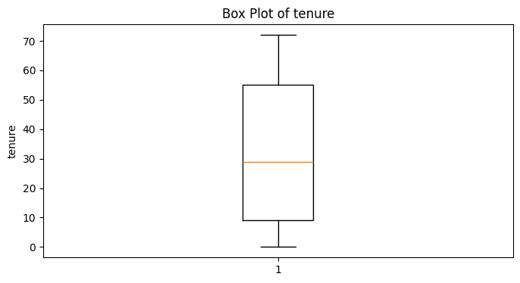
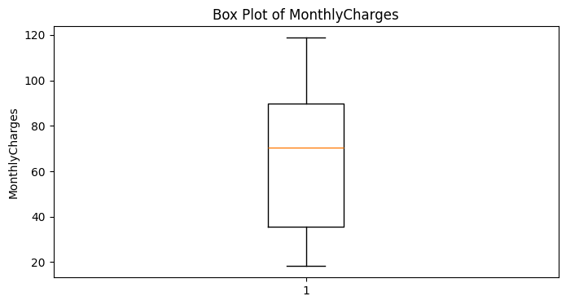
Categorical Encoding
Code:
binary_columns = [
"gender",
"Partner",
"Dependents",
"PhoneService",
"PaperlessBilling",
"Churn"
]
for column in binary_columns:
df_cleaned[column] = df_cleaned[column].map({
"Yes": 1,
"No": 0,
"Male": 1,
"Female": 0
})
One-hot coding
One-hot encoding was used for categorical variables containing multiple categories. The drop_first=True option was used to retain a reference category and reduce redundant encoded variables.
Identifier Removal
df_cleaned = df_cleaned.drop("customerID", axis=1)
customerID was removed because it uniquely identifies individual customers but does not provide meaningful predictive information for churn modeling. Retaining such identifiers could introduce unnecessary features without contributing useful behavioral information.
Feature Scaling/Normalization
Feature | Min | Max
tenure | 0 | 72
MonthlyCharges | 18.25 | 118.75
TotalCharges | 0 | 8684.80

The numerical variables had substantially different ranges, particularly TotalCharges, which had a maximum value of 8684.80. To place the continuous numerical variables on a comparable scale, Min-Max normalization was applied.
Code:
from sklearn.preprocessing import MinMaxScaler

scaler = MinMaxScaler()

df_cleaned[scaling_columns] = scaler.fit_transform(
df_cleaned[scaling_columns]
)
Result
Feature | Scaled Minimum | Scaled Maximum
tenure | 0 | 1
MonthlyCharges | 0 | 1
TotalCharges | 0 | 1

After transformation, all three continuous numerical features were scaled to the 0–1 range.
Feature Correlation Analysis
Positive Correlations
- InternetService_Fiber optic → 0.308
- Paymentmethod_Electronic check -> 0.302
- MonthlyCharges -> 0.193
- Paperlessbilling -> 0.192
Negative Correlations
- Tenure -> -0.352
- Contract_Two_year -> -0.302
- InternetService_No -> -0.228
Pearson correlation analysis was performed to understand the relationship between the available features and the target variable, Churn. The strongest negative relationship was observed for tenure with a correlation coefficient of approximately −0.352. Contract_Two year also showed a relatively strong negative relationship. On the positive side, InternetService_Fiber optic and PaymentMethod_Electronic check showed relatively stronger positive relationships with churn.Correlation was used for exploratory feature analysis rather than automatic feature elimination. Features with weak individual correlations were retained because they may still provide useful information when combined with other variables in a machine learning model.
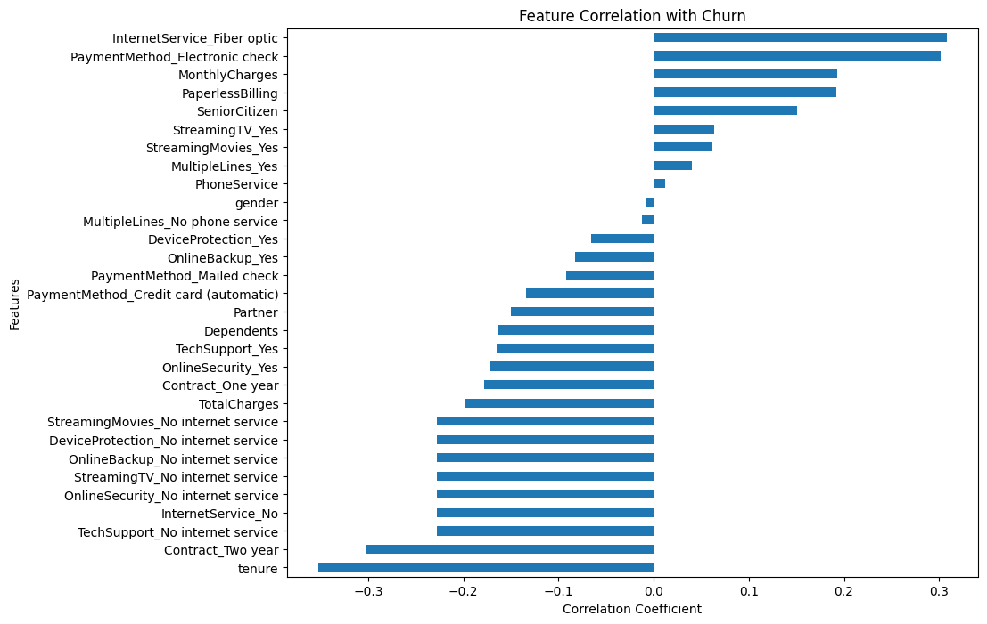
Final Dataset Validation
FINAL DATASET VALIDATION
Shape: (7043, 31)
Missing values: 0
Exact duplicate rows: 22
Object columns: 0
Infinite values: 0
Challenges Encountered and Solutions
Challenge 1 — TotalCharges stored as object
Problem:
TotalCharges was initially stored as an object/string column rather than a numerical column.
Solution:
Converted it using pd.to_numeric() and handled the resulting missing values.
Challenge 2 — Missing values
Problem:
Conversion of TotalCharges revealed 11 missing values.
Solution:
The missing values were handled during the cleaning stage, resulting in zero missing values.

Challenge 3 — Duplicate feature profiles
Problem:
After removing customerID, 22 rows appeared as duplicates.
Investigation:
33 repeated feature profiles were identified, and 18 had different churn outcomes.
Solution:
The rows were retained because they represented distinct customers with potentially identical characteristics.
Challenge 4 — Different numerical scales
Problem:
TotalCharges had a much larger numerical range than tenure and MonthlyCharges.
Solution:
Min-Max scaling was applied to the continuous numerical features.

Conclusion
The Week 1 task successfully established a complete data acquisition and preprocessing pipeline using Python. The customer churn dataset was inspected, cleaned, transformed, and validated using Pandas, NumPy, Matplotlib, and Scikit-learn.
Missing values were handled, data types were corrected, and duplicate records were carefully investigated. Outlier analysis using the IQR method identified no outliers in the selected numerical features. Categorical variables were converted into numerical representations using binary and one-hot encoding. Continuous numerical features were normalized using Min-Max scaling.
Correlation analysis provided additional insights into the relationship between customer characteristics and churn. The final dataset contained 7,043 records and 31 numerical columns, with no missing values, object-type columns, or infinite values.
The resulting dataset is therefore prepared for further exploratory analysis and machine learning modeling.

Future Scope
The preprocessed dataset can be used for further exploratory data analysis and machine learning tasks. Future work could include analyzing churn patterns across customer segments, performing feature importance analysis, splitting the dataset into training and testing sets, and developing classification models such as Logistic Regression, Decision Trees, Random Forest, or Gradient Boosting. Model evaluation can then be performed using metrics such as accuracy, precision, recall, F1-score, and ROC-AUC.

Appendix
- Data loading
- Dataset inspection
- Missing-value handling
- Duplicate checking
- Data type conversion
- Outlier detection
- Identifier removal
- Binary encoding
- One-hot encoding
- Min-Max scaling
- Correlation analysis
- Final validation

